Land Cruiser LC 200 Series to ARB BASE rack and Rhino Pioneer 2021) - Tough Touring Awning brackets - Installation instructions.
Be sure to remove belt buckles, sharp objects from your pockets if you don’t want to scratch your paint on vehicle. Cover paint areas with rags where possible and protect it against ladder strike etc.
Kit contents –

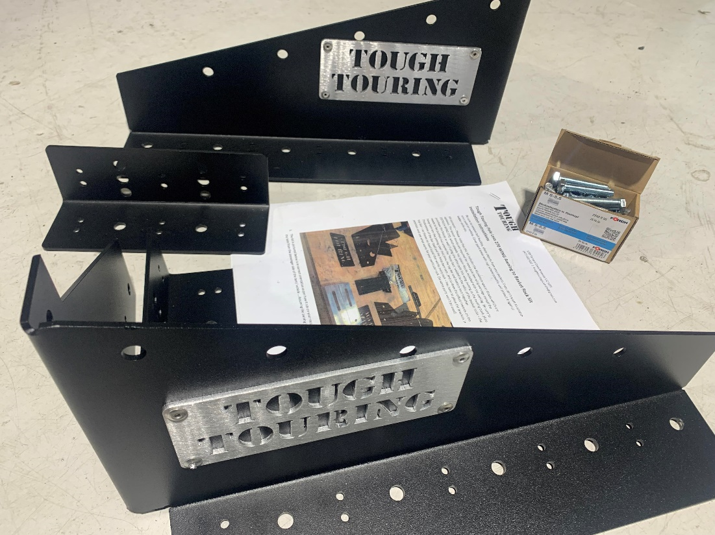
- The kit is pictured above has an 80mm outbound folded section on both the front and rear brackets, to ensure that correct positioning is achieved, the base needs to be installed flush with the rear of the rack... The 200 series wind fairing will foul on all awnings if the brackets are not positioned inward 80 mm from the rear as per the fold on the base of the brackets.
2. We have manufactured a ‘Variation’ of this design pictured below – It has slotted bolt holes to accept most North South plank channels on racks such as the Rhino Pioneer – Its also a close match to the Front runner Slimline 2 and Arb base racks which run an East west M8 track.
- The Rhino rack runs its own track size – requiring you to purchase their special ‘T BOLTS’ pictured below. – You can’t use an ordinary M8 bolt… They designed it this way. The T Bolts are able to be purchased at Rhino rack superstores, roof rack supercentre or on Ebay. We’d recommend 3 or 4 bolts on each bracket – Total of 8 required.
- Pics of the Rhino rack variation below and the T BOLT. 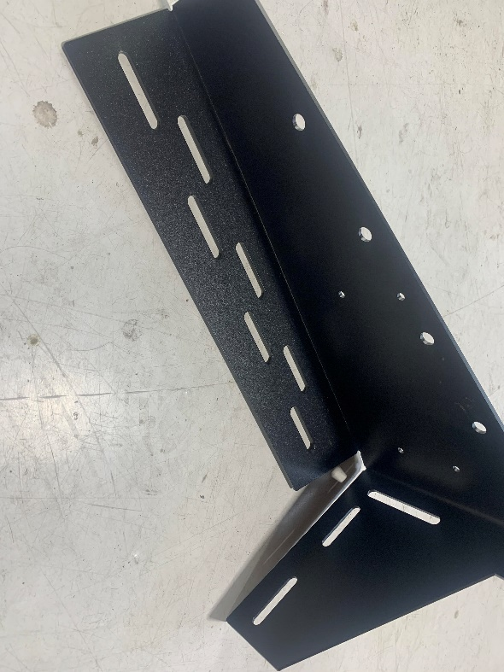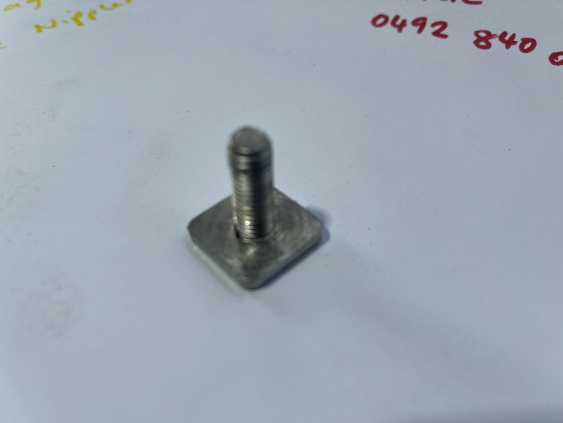
- If using the Slotted Variant BRACKET ABOVE on a 200 series Cruiser (or a 105 or a Y62) – make sure that you STILL mount the Bracket 80mm forward from the rear of the rack. This is to ensure you have enough room between the opened door for the awning to open up and swing around fully.

This bracket used for most types of pole less wing awnings and can accommodate Ostrich wings, Bundu Awns, Howling moon Awnings, Quick Pitch as well as 30 second awnings and Rhino Batwing.– The Bush Company XT and XT MAX...

There is a ‘Hook bracket’ Included in the Kit. NOTE that Not all awnings can use the included Hook bracket at rear drivers side, however it can be a handy place to hang rubbish bags / shoes etc anyway. (So you may as well fit it. )

- NOTES: BEFORE YOU START…
If you wish to use Factory Rhino T Bolts – Upwards into our Bracket kit, you can – but you will have to mark the Rhino SLOTS positions into the bracket and then drill the holes in the bracket to accept them. We don’t recommend doing this, it is not as strong an install, and the planks are not designed for these kinds of loads.

- We offer a ‘Stiffening plank’ to strengthen the Rhino rack – It is a Super ridged East west plank that we bolt up under the rear of the rack… Consider using one to stop the rack flexing as the awning lifts. You will know when your finished the installation if you need one. (It can be added later).. Most popular Racks were never designed for the loads exerted by pole less awnings, Be mindful that you are modifying the design and warranties on the rack are going to be void when subjected to the strain of these type of awnings.

THE BELOW INSTRUCTIONS ARE FOR THROUGH BOLTING THE BRACKETS TO YOUR RHINO RACK OR ARB BASE RACK. The princibles are the same for those of you that are going to use TBOLTS and bolt the brackets up without drilling the holes… But the rest of the instructions are the same.
- Included in the pack of fitting hardware + Open Aluminium 6/6 rivets, 6 bolts and nuts (For Fixing the Bracket to the rack ) a handful of tec screws to hold brackets in place on your tent while you drill out the holes for the rivets. – Some parts may not be needed but are included in case your short. It is normal to have parts left over 😊 You can use the Nutserts provided if you know how to use them for a better finish and Less holes in your rack.
- face plate at the correct distance… Typically all mount points are different. 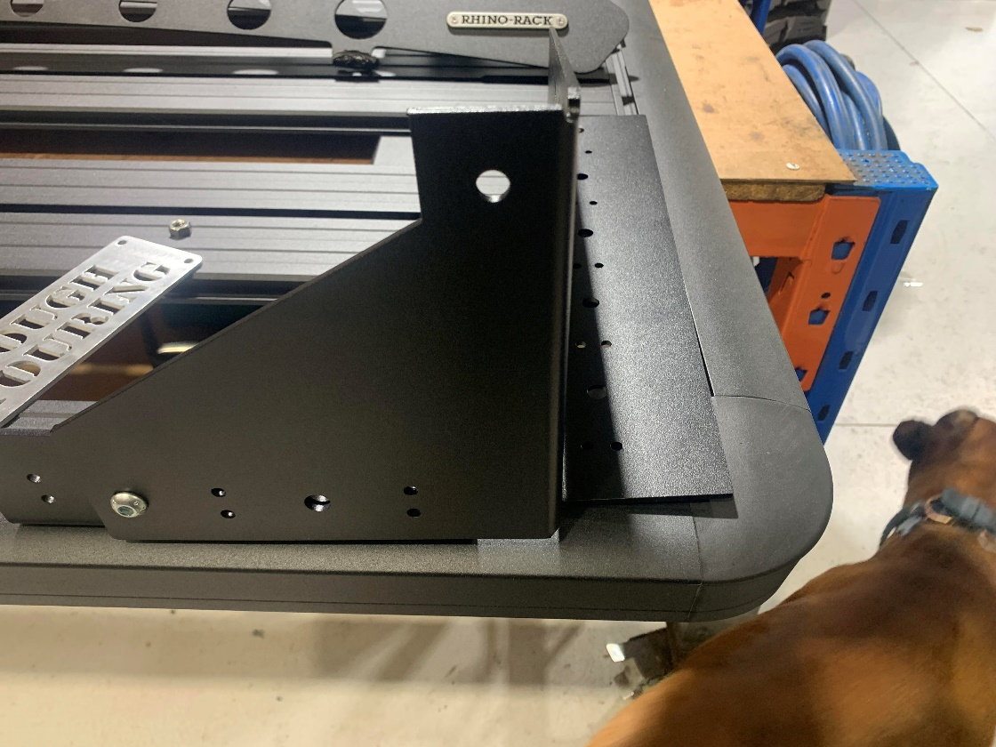

- Take the rear passenger corner bracket (the one Pictured above) and loosly attach (Finger tight Bolt on the inner folded angle bracket ) Put it on the rack where its going to go and have a look… … test fit this first. It is best fitted flush with the bottom edge.. In the Pic Above I’ve got it attached with one bolt forward about an inch of the face side of the bracket, as it lines up with two m8 bolts and 4 rivetts this way, as well as heaps of spots on the rhino rack.

- Now slide the assembled bracket into place on the rear passenger side so that the rear vertical face of the Bracket sits about 80 – 100mm inward from the end of the rack – You can move it around a bit from there to find a position where you can get the max amount of good solid fixing points through the top and end extrusions on your rack. Remember that the face edge needs to be close to flush with the outsdide face edge of your rack, however the position forward or backward can be anywhere from 80mm to 120 forward... A bit forward won’t hurt if your going to get more solid fixing points. See PIC below.

- 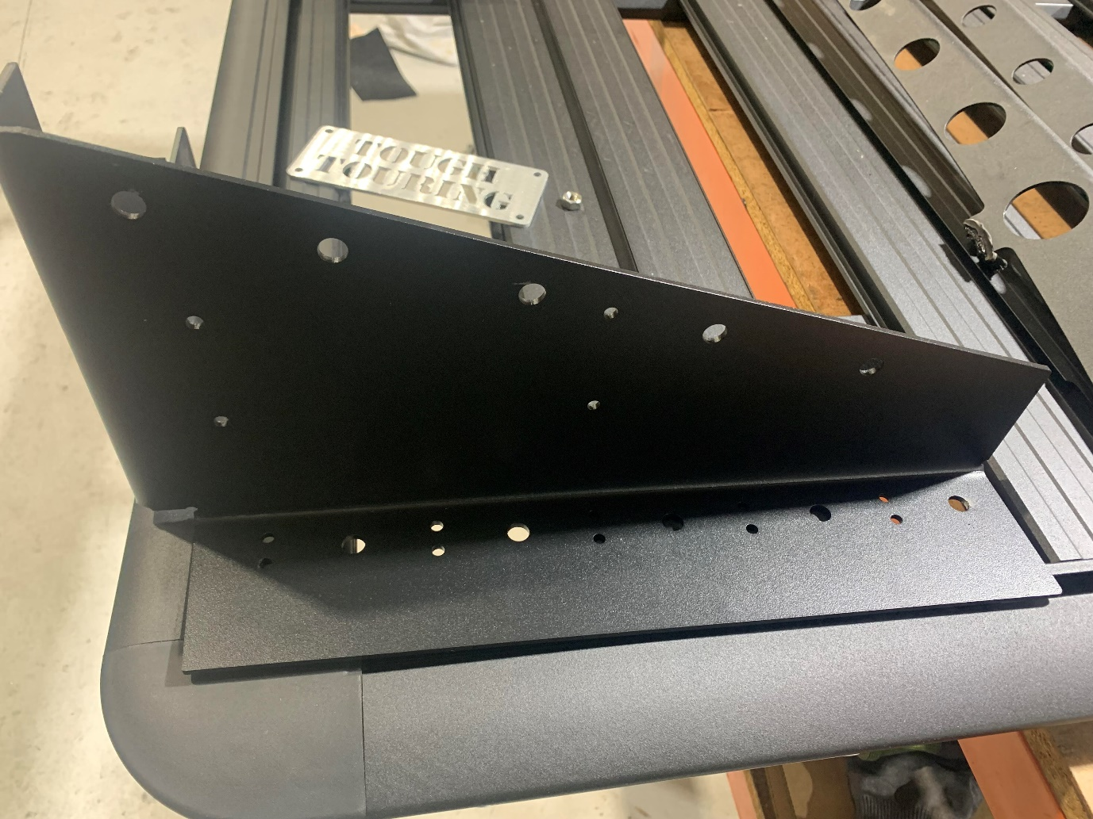

- (Modern Aluminium Plank racks like Rhino pioneer, ARB ascent and others have a large plastic corner radius, don’t bother fixing into it, it has no strength, the plates are oversized on our brackets to give you options to hit metal with rivets and bolts where you can.
- Now that you have found the best / strongest Position your bracket on the rack, tec screw it into position as a ‘test fit’ using 2 tec screws. Check that it sits level. And square. There is an example of one fitted below... (Its not the same kit but very similar) – Note I’ve put 4 rivetts along the back plate into the rack edge – the two hex head bolts actually sit just below the rack edge and are bolted to the right angle backing bracket – which in turn is bolted through the top of the rack as in pic below this one…

- As your taking out the Tec Screws one at a time, Youdr drilling out the holes they have left at 9 mm and then through bolting the bracket to your rack using the M8 Bolts provided. I like to drill and bolt, drill and bolt, drill and rivett, drill and rivett.
- We would recommend 3 bolts on the rear of the bracket (One As far out towards the end of the bracket as far as possible to prevent twist) and one bolt or 4 rivetts on the face of the bracket. (The face being the side the awning bolts up too). We’d reccomend Rivets only on the facing ends of the Pioneer and Ascent racks in particular, as they have bevelled edges making it hard to get a bolt in them square… For these racks, use 3 bolts instead through the top planks, as well as a spread of rivets to secure the load. Typically 3 bolts and 10 Rivetts is enough in the rear plate. If you have to drill some new mounting holes in the bracket – do so. But don’t over do it. Think about the awning twist – preventing twist is the key.
NOTE that you will see some pics here and there of Tough Touring Brackets which show the bracket wrapping around the sides of the rack - you can’t do this on the 200 series, as the awning ends up lower and back far enough to but unable to open the back door...
- YOU HAVE TO MOUNT THE AWNING BRACKET ON TOP OF THE RACK on the 200 series.. (and Forward 80mm at least for room for the swing round last arm).

- Now to repeat same technique for the front bracket, If you have the rear on – you will already know what to do on the front.
- Be mind ful that your rack is not LONGER than your awning. If so, make sure your front MOUNT Bracket is positioned within the mounting points available on your awning.

- test fit the front bracket as per the rear one. Get a measurement from the awning mounting holes on the brackets face plates centre to centre, before fitting it all off permanently, again make sure your awnings back plate has the length to reach to the front bracket.

- If you wish to use Factory Rhino T Bolts – Upwards into our Bracket kit, you can – but you will have to mark the Rhino SLOTS positions into the bracket and then drill the holes in the bracket to accept them. We don’t recommend doing this, it is not as strong an install, and the planks are not designed for these kinds of loads.

- We offer a ‘Stiffening plank’ to strengthen the Rhino rack – It is a Super ridged East west plank that we bolt up under the rear of the rack… Consider using one to stop the rack flexing as the awning lifts. You will know when your finished the installation if you need one. (It can be added later).. Most popular Racks were never designed for the loads exerted by pole less awnings, Be mindful that you are modifying the design and warranties on the rack are going to be void when subjected to the strain of these type of awnings.

- Now you can install the rear ‘hook‘ bracket (which is ONLY REQUIRED for 270 Degree awnings) this allows you to swing the awning around and clip it onto the bracket rather than using the awnings tensioning strap. (this is NOT COMPULSORY and DOES NOT SUIT ALL AWNING TYPES). Its wise to install the awning to the brackets, then open it up and secure it with the included awning strap first. This will give you the right position for the hook bracket. (And hold the awning open while you test install it with tec screws) – Once the awning is put away and your happy with the hook brackets position, pull out the tec screws and rivett it on, filling the holes made by the tec screws by replacing them with the rivetts. You will need to drill the rivet holes out one at a time with a 6mm drill bit first or the rivetts won’t fit. (Tec screws leave a 5mm hole).
A FEW EXAMPLES OF THE BRACKETS ALL BOLTED UP BELOW>… THESE ARE ALL THE PRE _SLOTTED PICS – SO HOLES HAVE BEEN DRILLED IN THE RACKS ON THE RHINO.
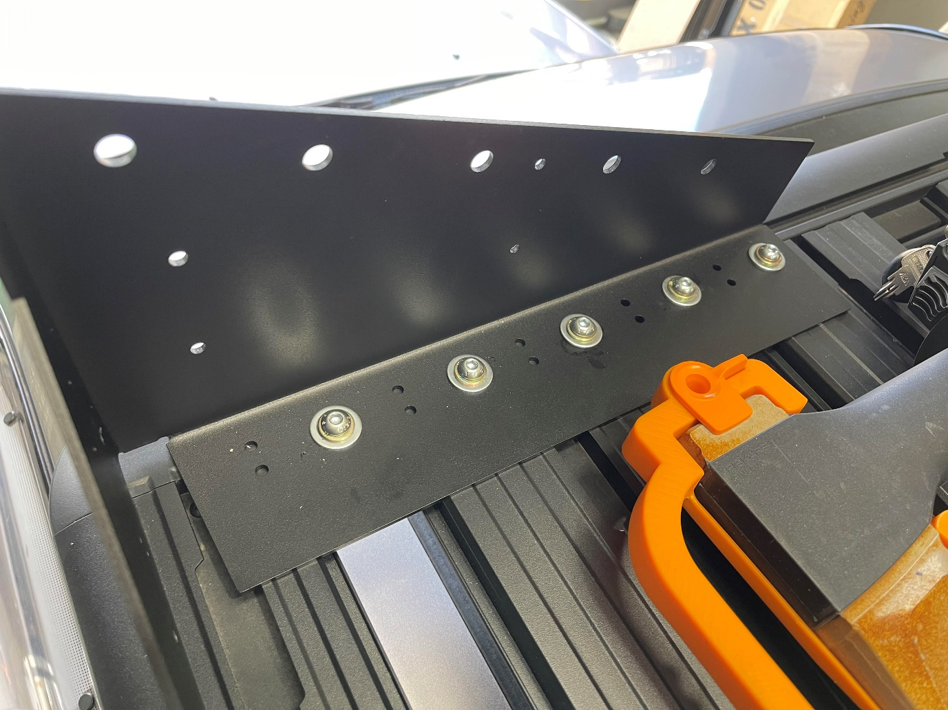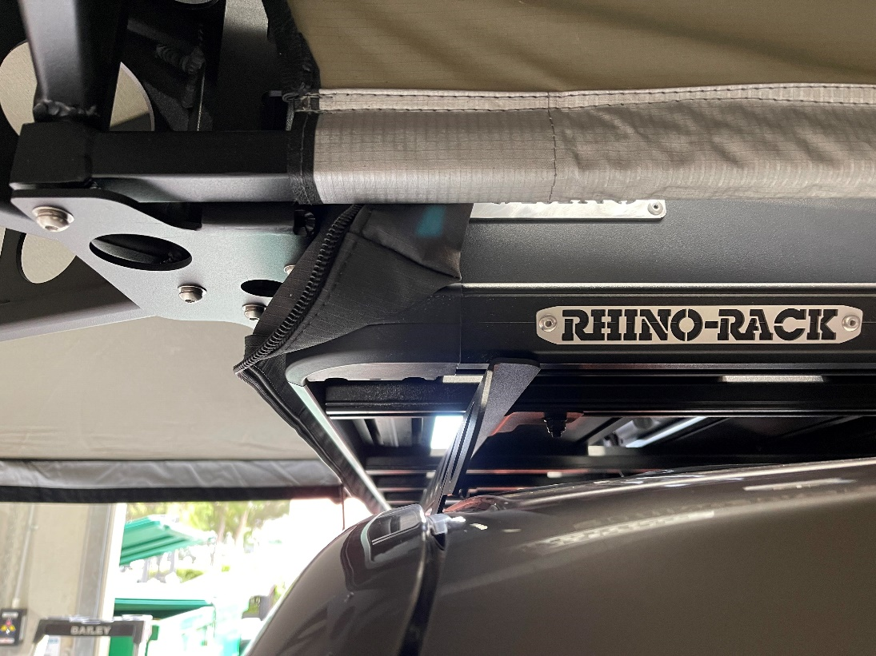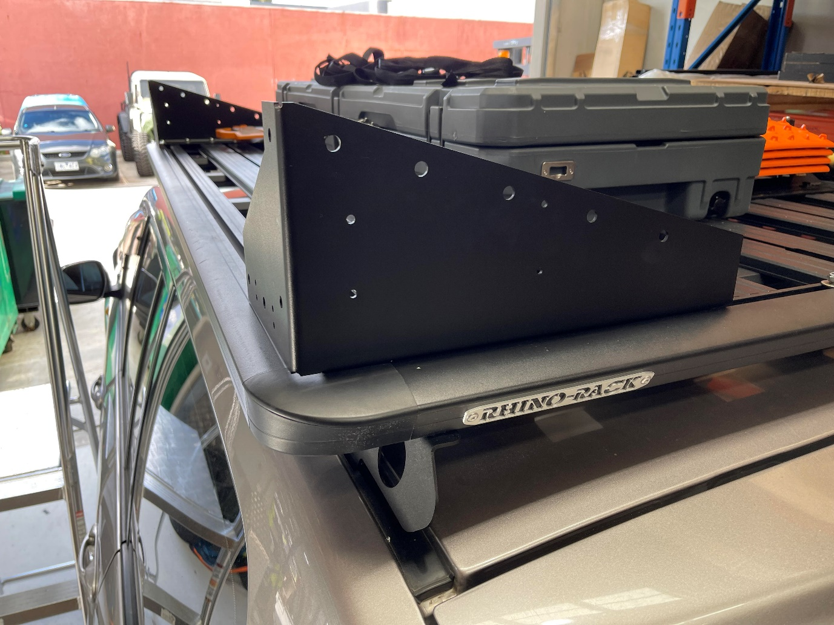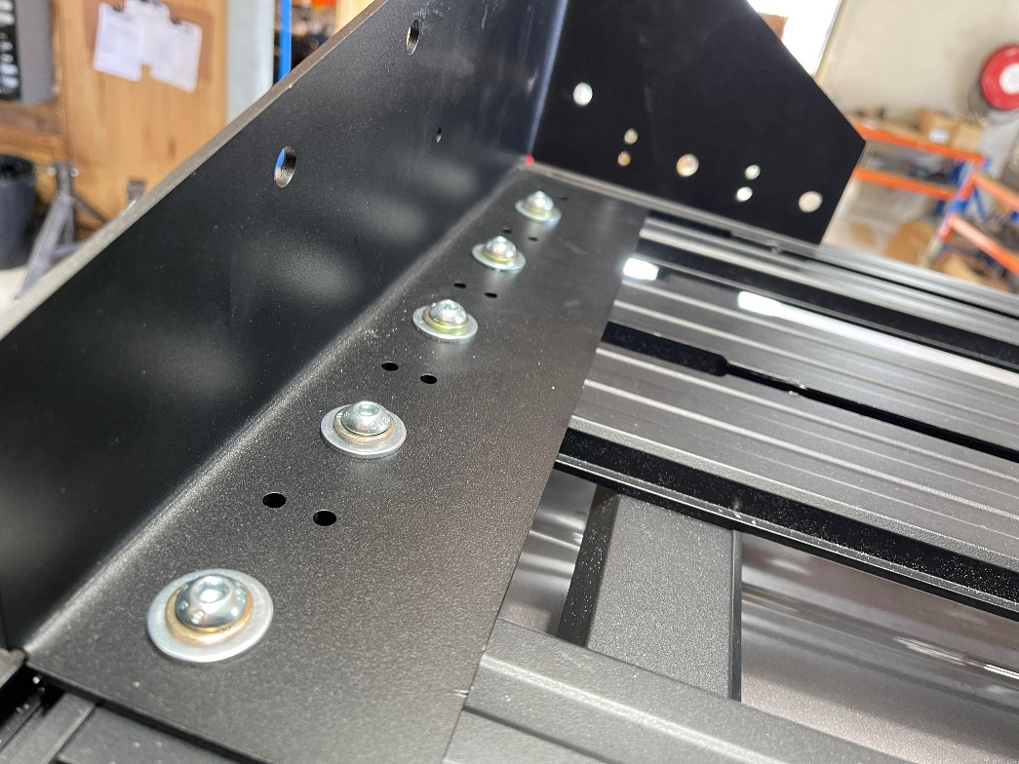

- There is a Pair of our Logo plates that you can install on the brackets once your done… Go On ! they look better on… 😊 They Rivet on in pre – drilled holes.
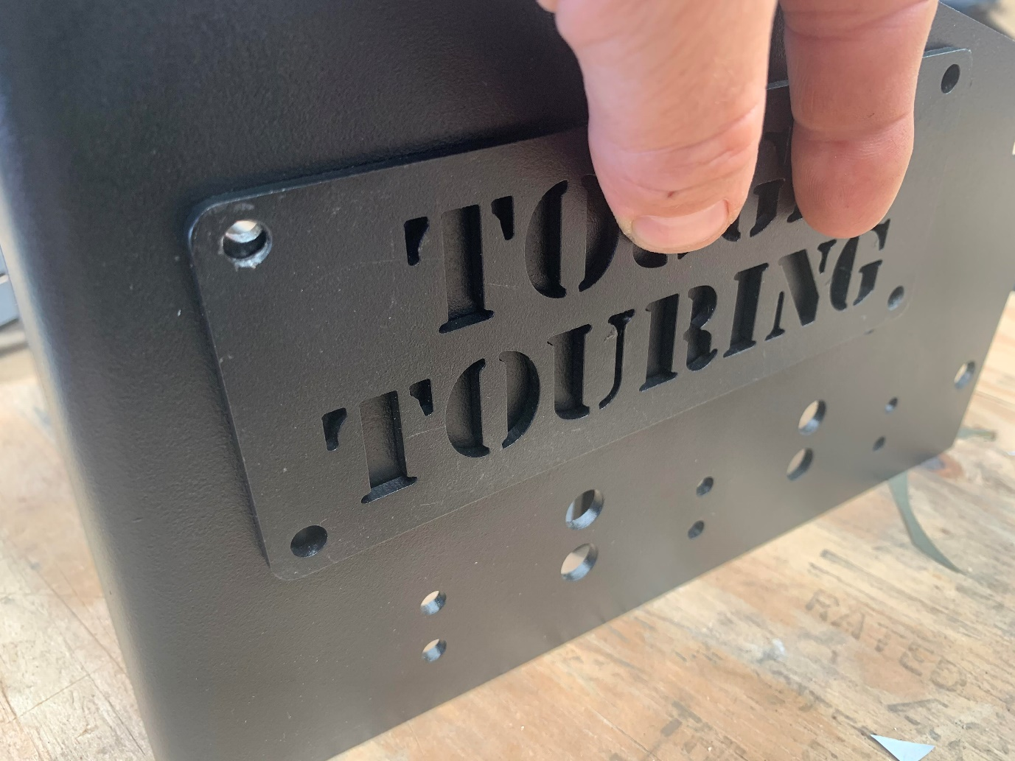

- NOTE It is always better to measure twice and drill once! Take time and care to get the test fit straight and the rest of the installation will run smoothly. Get things square. Get them straight. Position all your brackets with test fit tec screws and open / close the tent to ensure you have the set up correct before you drill all the rivet holes.

- When using your awning, use Guy ropes and poles if any movement is evident in wind. Always pack your awning when unattended – wind will exert extreme loads on pivot points – especially in directions facing the awning. Don’t break things and find out later blaming the awning. The wind will always win 😊

- Enjoy your awning! 😊 On this 200 Series landcruiser – we had to move the rear sliding mounting plate on the ostrich awning back 70mm to the rear bolt holes to get a PERFECT fit between the ARB rack and the Wing fairing…. Lets just say that the LC200 is a tricky installation… Lets just say that EVERYTHING you touch on a 4wd will throw obstacles at you. There will always be things in the way and stuff that goes a bit wrong. Part of 4wd Mods really. Shrug it off and put the tools down if your stressing out. Your head will work better after a nights rest, and solutions for the puzzles will appear.

- Add your hook bracket. Set up the awning, Slide the hook bracket in place on the drivers side rear and tec screw, Remove awning tension and pull out tec screws and rivet it in place…

- JOB DONE.

